Temperature and humidity sensor

using DHT11 module

I wanted to test the functionality of the DHT11 temperature and humidity sensor module using Arduino MEGA 2560. Instead of sending the output of the DHT11 to the serial monitor I wanted to see it on a LCD display. Ended up with a weird looking room thermometer that looks like this:

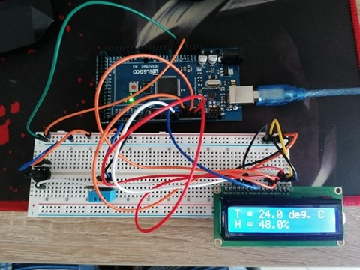

The circuit for this thermometer looks like follows:

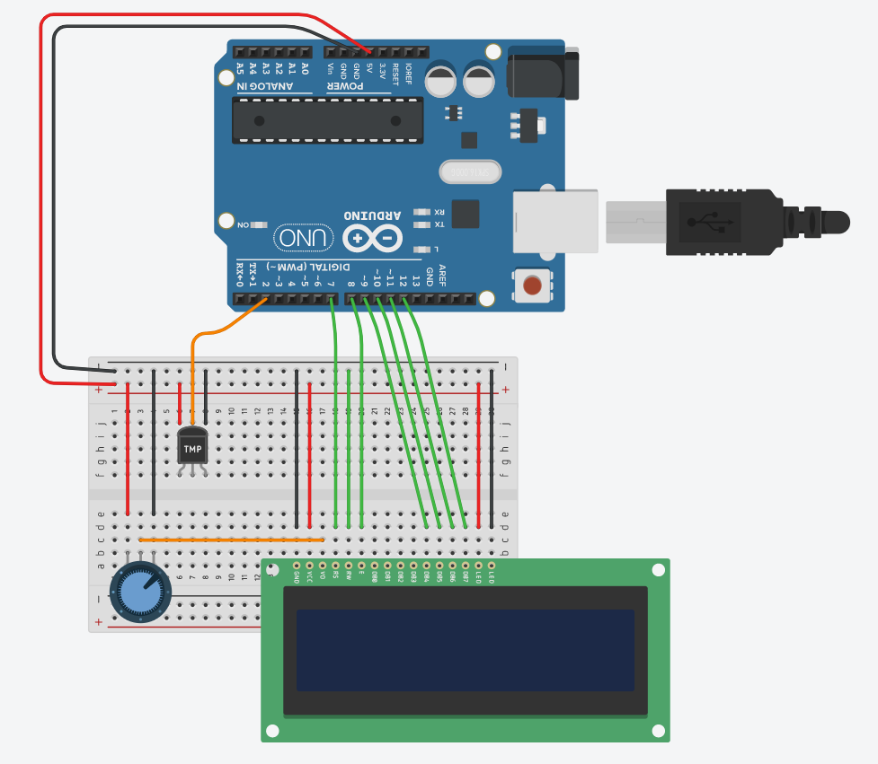

I have connected the DHT11 digital output pin to pin 2 of the Arduino and the Power + and – to the Arduino’s 5V and GND respectively. A 10K potentiometer to pin 3 of the LCD to control the contrast.

In the Arduino IDE I included the DHT and LCD libraries and initialized the pins for the display and the input of the DHT11:

#include <dht_nonblocking.h>

#include <LiquidCrystal.h>

// initialize the library with the numbers of the interface pins

LiquidCrystal lcd(7, 8, 9, 10, 11, 12);

#define DHT_SENSOR_TYPE DHT_TYPE_11

static const int DHT_SENSOR_PIN = 2;

DHT_nonblocking dht_sensor( DHT_SENSOR_PIN, DHT_SENSOR_TYPE );

/* Initialize the serial port. */

void setup( )

{

Serial.begin( 9600);

lcd.begin(16, 2);

}

Then I created a function that reads the digital output of the DHT every four seconds and returns true if a measurement is available.

/* Poll for a measurement, keeping the state machine alive. Returns

true if a measurement is available. */

static bool measure_environment( float *temperature, float *humidity )

{

static unsigned long measurement_timestamp = millis( );

/* Measure once every four seconds. */

if ( millis( ) - measurement_timestamp > 3000ul )

{

if ( dht_sensor.measure( temperature, humidity ) == true )

{

measurement_timestamp = millis( );

return ( true );

}

}

return ( false );

}

Then, in the main loop, the previous function is called and if it returned true, the results are displayed on the LCD.

void loop( )

{

float temperature;

float humidity;

/* Measure temperature and humidity. If the functions returns true, then a measurement is available. */

if ( measure_environment( &temperature, &humidity ) == true )

{

lcd.setCursor( 0, 0 ); /* sets the cursor on the first line and first collumn of the display */

lcd.print( "T = " );

lcd.print( temperature, 1 );

lcd.print( " deg. C" );

lcd.setCursor(0, 1); /* sets the cursor on the second line and first collumn of the display */

lcd.print( "H = " );

lcd.print( humidity, 1 );

lcd.print( "%" );

}

}